[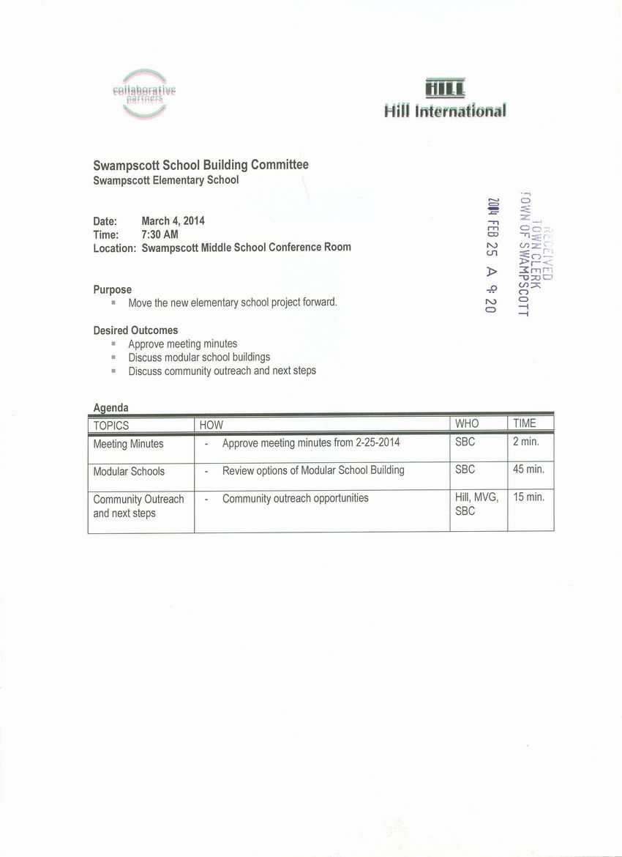](http://www.town.swampscott.ma.us/Public_Documents/SwampscottMA_Calendar/S04628CA0-0462F56D.0/School%20Building%20Committee%20March%204th%20notice%20001.jpg)